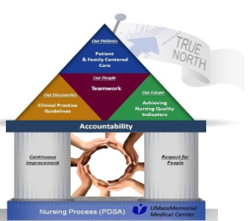
2020 Celebrating National Nurses Week
Three $2500.00 scholarships will be awarded to caregivers who exemplify the standards of respect in the art of nursing in their clinical area.
Complete the below information and email it to nursingexcellence@umassmemorial.org or complete online https://www.surveymonkey.com/r/2020nursingscholarships by April 1, 2020
Name of Candidate:

Campus: | Unit/Department:
Name of School: | Anticipated graduation date:
Name of Nurse Manager: | Date of hire:

Candidate Academic Criteria: | Scholarship
Unlicensed Caregiver (example: PCA, MHA, ASR) who is actively enrolled in a Nursing program | Lamonda Scholarship
RN who is actively enrolled in an RN-BSN program | Alden P. Johnson Scholarship
RN who is actively enrolled in a Master’s or Doctoral program | Alden P. Johnson Scholarship
*Please note that scholarships will NOT be awarded to candidates who are completing a program in the Spring of 2020
Attach a copy of your resume to this application
Professional Goal Statement: (in 2-3 sentences, describe your professional goals and aspirations)

Submission
Select one of the six Standards of Respect below and describe 1-2 examples of how you exemplify that criterion in the art of nursing. (No more than 400 words.)
Acknowledge | Notice others and recognize their contributions or concerns
Listen | Give your full attention to show you understand and care about what others say
Communicate | Share appropriate information generously and as soon as possible with those who need it
Be Responsive | Respond in the expected time frame to show others’ priorities are important to you, too
Be a Team Player | Do your work in a way that also helps others
Be Kind | Choose to be friendly, patient and compassionate- even when it’s easier not to
Insert Narrative Here:

